Undelete a box.docx

Go to Data entry > Box, find the box. Notice that is it greyed out.

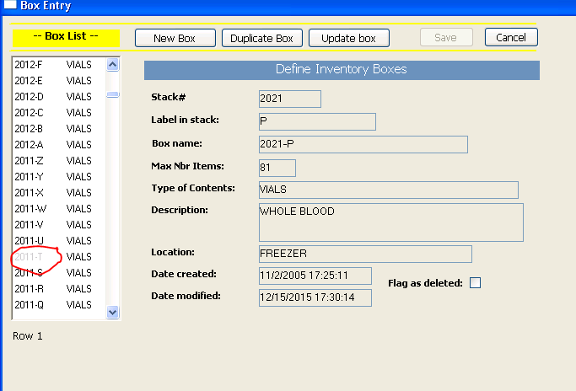

Click the box, then the ‘Update button’ to put the window in edit mode. Uncheck the ‘Flag as deleted’ check box, then click Save.

Now in Data Entry > Inventory, you can call up the box and see its contents:

